KJSCE/IT/SYBTech/SEM IV/WP1/2022-23

# Tutorial No. 04

**Title:** CSS3 – Background, Gradient, Opacity, Drop shadows,

Transition, Transformation, Pseudo selectors and Pseudo element**.**

|  |  |  |
| --- | --- | --- |
|  |  | KJSCE/IT/SYBTech/SEM IV/WP1/2022-23 |
| **Batch: B2** | **Roll No.: 16010421119** | **Tutorial No.: 4** |

**Aim**: To design a Web page using HTML 5 and stylise it using CSS3 – Background, Gradient, Opacity, Drop shadows, Transition, Transformation, Pseudo selectors and Pseudo element.

## Resources needed: Notepad++, Web Browser

**Theory:**

## Activity

Design a web page using the CSS properties like Colors and Background-color,Lengths and percentages,Margin and padding,Borders,Navigation bars , Background, Gradient, Opacity, Drop shadows, Transition, Transformation, Pseudo selectors and Pseudo element. etc.

## Results: (Program printout with output)

<!DOCTYPE html>

<html lang="en">

<head>

<meta charset="UTF-8">

<meta http-equiv="X-UA-Compatible" content="IE=edge">

<meta name="viewport" content="width=device-width, initial-scale=1.0">

<link rel="stylesheet" href="style.css">

<title>Document</title>

</head>

<body>

<nav>

<ul>

<li><button id="btn1">Hover Button</button></li>

<li><a href="#" id="link1">Visited Link</a></li>

<li><a href="#" id="link2">Hover Link</a></li>

<li><button id="btn2">Hover Effect</button></li>

</ul>

</nav>

<form id="form">

<input type="text" id="focus" placeholder="Focus On the Button" />

</form>

<div class="image-flex">

<div class="row1">

<div class="col">

<img src="img.jpg"

id="transparent1" alt="">

</div>

<div class="col">

<img src="img.jpg"

id="transparent2" alt="">

</div>

<div class="col">

<img src="img.jpg"

id="transparent3" alt="">

</div>

<div class="col">

<img src="img.jpg"

id="transparent4" alt="">

</div>

</div>

<div class="row2">

<div class="col">

<img src="img.jpg"

id="transparent1" alt="">

</div>

<div class="col">

<img src="img.jpg"

id="transparent2" alt="">

</div>

<div class="col">

<img src="img.jpg"

id="transparent3" alt="">

</div>

<div class="col">

<img src="img.jpg"

id="transparent4" alt="">

</div>

</div>

</div>

</body>

</html>body

{

width: 100%;

height:100vh;

background: linear-gradient(rgba(131, 247, 145,0.3),rgba(35, 252, 62,0.4));

background-repeat: no-repeat;

}

nav{

background-color: green;

}

ul{

list-style: none;

display:flex;

flex-direction:row;

justify-content: center;

}

ul li{

margin: 10px 30px;

}

**#btn1:hover::before{**

**content: "Hello Brooo ";**

**}**

**#btn2:hover::after{**

**content: " Byee Brooo";**

**}**

#link1{

text-decoration: none;

}

**#link1:visited{**

**color: violet;**

**}**

.row1{

float: left;

display: flex;

flex-direction: row;

justify-content: space-between;

}

.row2{

float: right;

display: flex;

flex-direction: column;

justify-content: space-between;

}

#transparent1{

width:300px;

height: 300px;

margin: 10px;

**opacity: 0.5;**

}

#transparent2{

width:300px;

height: 300px;

**opacity: 0.2;**

margin: 10px;

}

#transparent3{

width:300px;

height: 300px;

**opacity: 0.8;**

margin: 10px;

}

#transparent4{

width:300px;

height: 300px;

**opacity: 0.1;**

margin: 10px;

}

**#focus:focus{**

**background-color: black;**

**color: white;**

**}**

**#transparent1:hover{**

**opacity: 1;**

**}**

**#transparent2:hover{**

**opacity: 1;**

**}**

**#transparent3:hover{**

**opacity: 1;**

**}**

**#transparent4:hover{**

**opacity: 1;**}

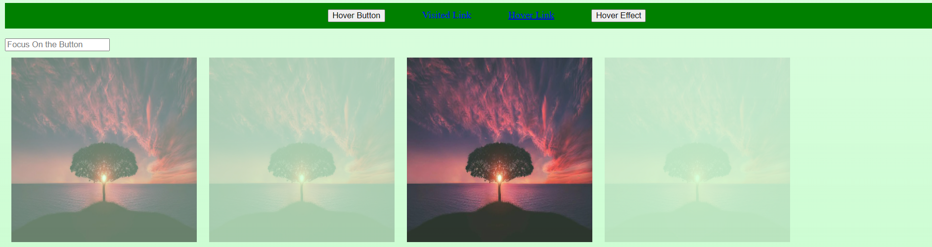

**Outcomes:**

**CO2: Create Web pages using HTML 5 and CSS**

**Conclusion: (Conclusion to be based on the outcomes achieved)**

**We can conclude that we have learnt about :-**  CSS3 – Background, Gradient, Opacity, Drop shadows,

Transition, Transformation, Pseudo selectors and Pseudo element**.**

## Grade: AA / AB / BB / BC / CC / CD /DD

Signature of faculty in-charge with date

**References:**

**Books/ Journals/ Websites:**

* “Web technologies: Black Book”, Dreamtech Publications
* [http://www.w3schools.com](http://www.w3schools.com/)